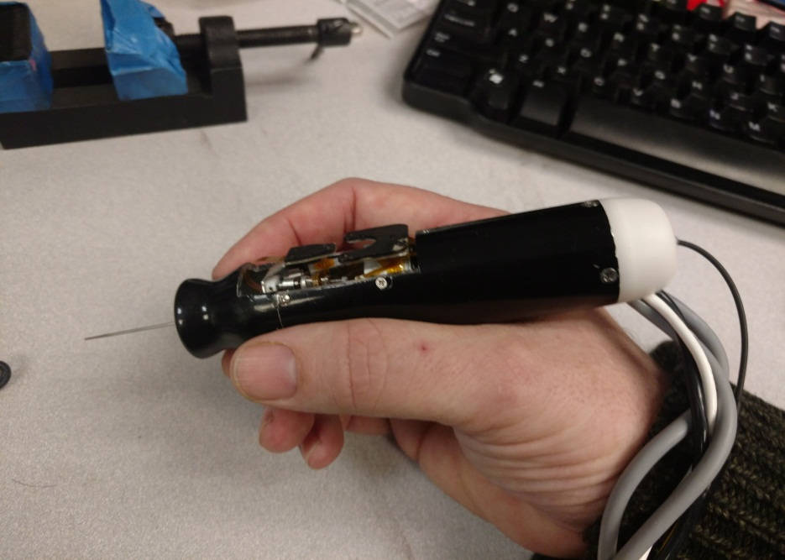

Finger Notch

LED mounts

Housing front

Housing tube

Housing back

Offset cable leadout

Center fiber conduit leadout

Output plate

Base plate

This photo shows the three main parts of the current housing design, front, tube, and back, with ergonomic features. Note how the handpiece sits in the hand, and the cables lay on the wrist for support, so that the cable weight doesn’t torque the tool. The housing front part is mainly an ergonomic feature. Note how it sticks out in front of the output plate. This is not mechanically desirable because it increases the moment at the tool tip and at the side load point (remote center of motion or RCM), but extending the housing out in front allows it to have the reduced radius finger notch, which gives a more desirable grip in the hand. The housing tube extends a considerable distance back from the manipulator base, giving room for electronics, cable termination and strain relief. It would not be desirable for the handle to extend much longer than this version because this affects the balance of the tool in the hand (CG should be in the middle or somewhat forward), and cable tension would torque the handpiece. A somewhat larger diameter is something that we can live with.

Application tool moments and workspace definition:

Tip workspace volume

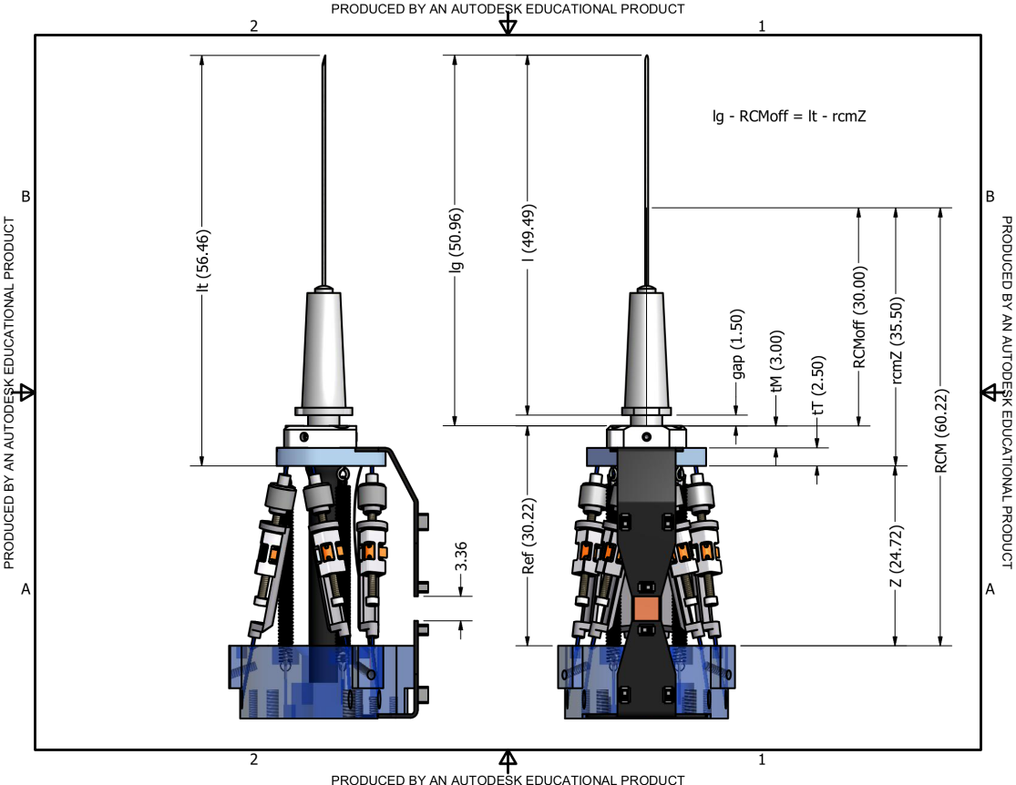

RCM pivot point

Z = 0

reference

Kinematic center

One requirement that we have used to design the manipulator is the scenario of “RCM motion”, where the RCM pivot on the tool shaft remains fixed as we move the tip throughout a cylindrical workspace. I don’t think we actually reliably achieved this with the current manipulator, but our goal was to get a 4x4mm dia tip workspace in RCM motion mode. You can see with this particular tool, the moment from RCM to tip is 20mm, vs. 37mm from kinematic center to RCM. So we need to translate nearly +/- 4mm in XY at the KC to achieve this RCM workspace. That is, more like an 8mm dia X 4mm height KC workspace.

Workspace definition:

Output plate

Kinematic center workspace volume

(Sets translation range)

4x4mm

Kinematic constraint circle. Tool axis must pass through this.

(Sets angular range)

4mm dia

Constraint circle is 26mm from kinematic center volume

This is the model of the manipulator workspace that I use in the kinematic code for the current manipulator. Advantages of this model are:

1. Does not depend on tool length, which is variable.
2. Does not depend on the RCM motion model, which even when we are trying to do RCM motion does not fully describe what we are actually doing to implement the commanded motion + stabilization.
3. More accurately represents the true mechanical constraint. Think of the constraint circle as representing the front opening in the handle.

I can tune these parameters to represent a good approximation of whatever the manipulator/housing combination supports. It’s easy to see that with these particular parameters and the tip/rcm positions in the previous drawing, we *can’t* reach a 4x4mm tip workspace volume using RCM motion (though we can do so without the RCM constraint). I’m not sure that Sungwook was even trying to do that with this manipulator version. Maybe 2x2?

Here’s an exploded view showing how the housing breaks down, and how the innards fit inside. The top part is a shroud for the LEDs, which is not shown in the photo. We haven’t been using this part.

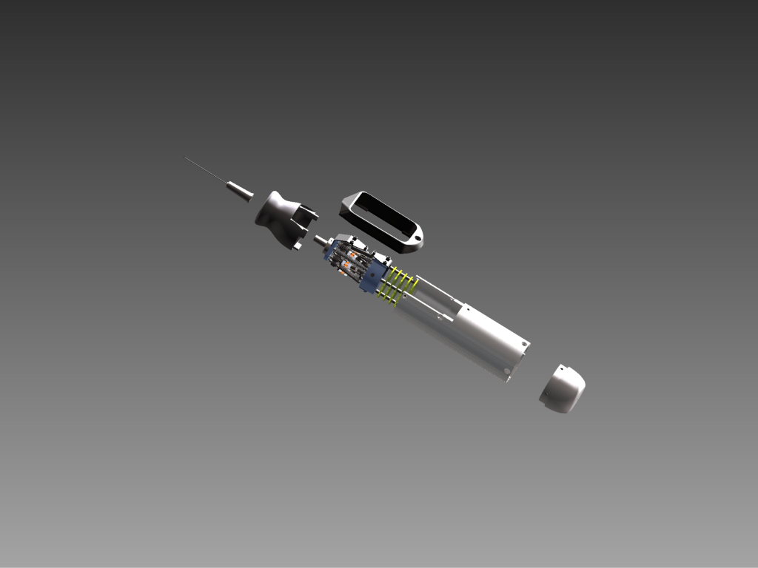

Mass is an important consideration in the housing design:

1. We want a considerable amount of mass rigidly coupled to the manipulator base. This provides a mechanical “ground” for the control system, reducing high-frequency instabilities and smoothing out vibration.
2. We want to keep the balance point forward so that the handpiece doesn’t want to topple backward out of the hand.

We initially made the manipulator base plate from plastic and experimented with various 3D printed housings and stock metal tubing. All plastic was just not enough mass. In the current version, the baseplate and housing are all machined aluminum, except for the back plug, which is plastic.

The desired balance point is roughly where the baseplate is, so adding mass there helps the vibration and control issues, and doesn’t harm the balance. The baseplate needs a really rigid connection to the other housing components (and their mass). For balance, the most useful mass component is the housing front. We deliberately made the very front end far thicker than it structurally needed to be. Though I think we never got around to this, we had considered making it out of stainless for extra density. The housing tube provides the rigid connection between the baseplate and the housing front. There is more mass and strength than really necessary in the back part of the housing tube, and this is not great for the balance. I think we stuck with a single part and a moderately thick wall for simplicity and ease of machining. Mass is not desirable in the housing back, so we made this out of plastic.

Baseplate:

See SWYANG\020813\Drawings\Micron_New_Rev_Base.dwg (second page in DWG has more dimensions)

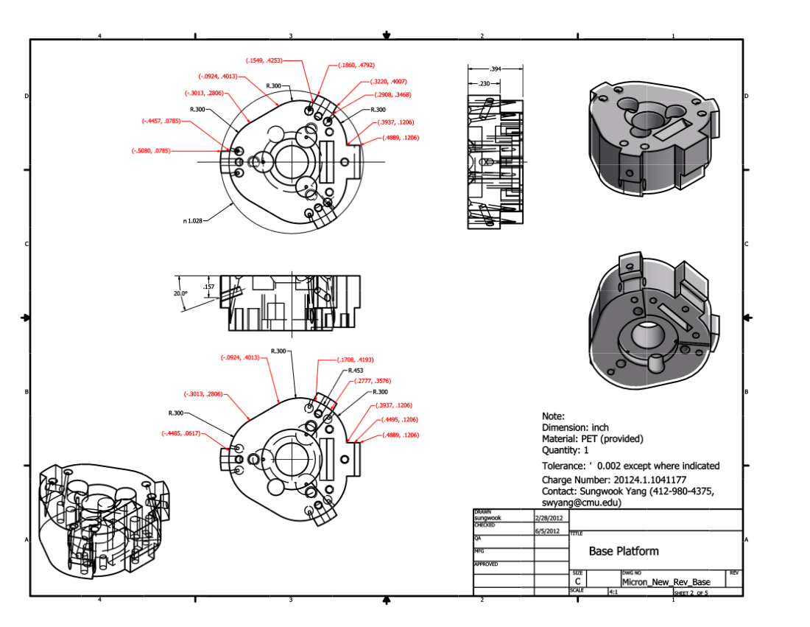

Slot for output LED flex

Footprint for base LED mount

Upper end of fiber conduit seats here

Mounting bosses seat on flange machined in housing tube. Inclined screw hole draws base down

My guess is that this particular mounting footprint for the base LED mount is not going to make sense in your design. That is, even if you can put this footprint somewhere, it may not be located correctly with respect to the window in the housing, so it would make more sense to redo the LED mount.

Housing front:

See SWYANG 020813\04192012_New_Front_2pcs\New_Front_Base_rev.ipt

Note excess material at front end for added mass. If you could transition your housing down to this same outer profile at the front end, that would be great. It really is not possible to handhold the tool without this part assembled on because your fingers interfere with the moving parts. The details of how this part mechanically interfaces to the rest of the housing are up to you. For what it’s worth, our screw holes in this aluminum part have stripped out from repeated reassembly.

